Ansible Assignment 3

Tasks To Be Performed: 1. Create 2 Ansible roles 2. Install Apache2 on slave1 using one role and NGINX on slave2 using the other role 3. Above should be implemented using different Ansible roles

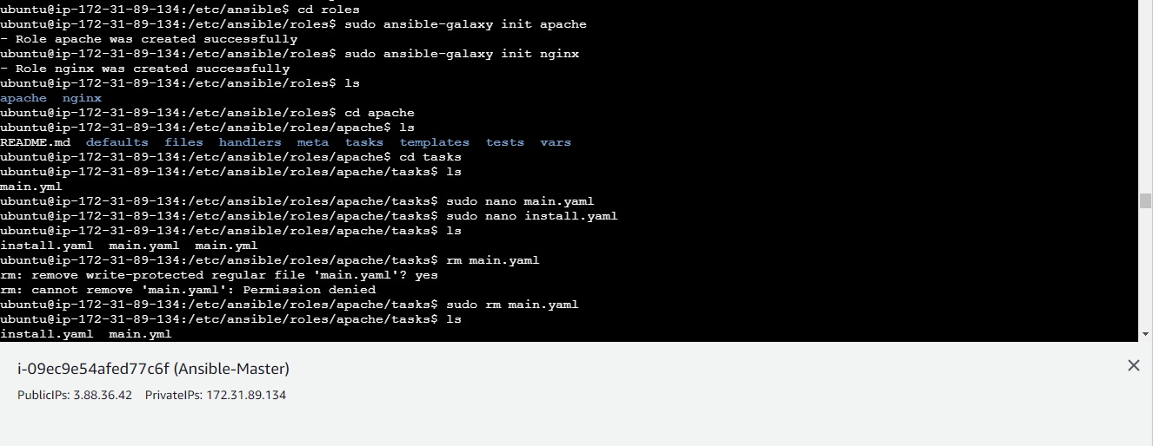



*2. Install Apache2 on slave1 using one role and NGINX on slave2 using the other role*

path of Ansible Apache role

/etc/ansible/roles/apache/tasks/

path of Ansible nginx role

/etc/ansible/roles/nginx/tasks/

add the yaml playbook files inside tasks

